Justin Cabral

ECE/CS 578

Assignment #4

1. ElGamal Encryption

Encrypt the following messages using ElGamal encryption (Z∗409 and g = 19):

(a) Private key x = 301, ephemeral key k = 23, message m = 59.











(b) Private key x = 301, ephemeral key k = 135, message m = 59.













2. ElGamal Encryption Concepts

Considering the examples from problem 1, we see that the ElGamal encryption scheme is non-deterministic: A given message m has many valid encryptions.

* (a) Why is the ElGamal encryption scheme non-deterministic?

**Answer**: The reason the ElGamal encryption scheme is considered non-deterministic is because of the value k, which is randomly chosen each time Alice wants to send a message to bob using the public information he provides to her. Without the random choosing of k, it would be deterministic.

* (b) How many valid ciphertexts are there for each message m (general ex- pression)?

**Answer**: There are [2 … (P – 2)] valid ciphertexts for each message m.

* How many are there for the system in problem 1 (numerical answer)?

**Answer**: There set of possibilities is [2 … 407] which is 405 different possible cyphertexts for each message m in problem 1.

* (c) Consider the case that for two messages m1 ̸= m2 the same ephemeral key k1 = k2 has been chosen for the ElGamal encryption. This kind of behavior occurs if no or a bad cryptographic PRNG is being used. Show how the message m2 can be recovered from a known message ciphertext pair m1,c1 if the same k is used.

**Answer:** Given an unknown m1, and a given m2, c1, and k, we can find m2 by doing the following

Form1: c1 = 𝑔^k 𝑚𝑜𝑑 𝑝 and d1 = m1 * g^𝑎𝑘

For m2: c2 = 𝑔^k 𝑚𝑜𝑑 𝑝, and d2 = m2 * 𝑔^𝑎𝑘

Since 𝑘 is the **SAME** in both encryptions, by dividing d1 and d2 we have:

d1/d2 = m1/m2 => d1 * m2 = d2 * m1

m2 , d1 and d2 and are now known, so we can calculate m1. This example shows why we should never use the same k when encryping diferent messages in the El Gamal scheme.

3. Implement the square and multiply algorithm using a computer language of your choice (I recommend sage, python, java, or other math environments such as magma. The environment should have native BigInteger support, so do not use C/C++ etc.). The program should print all intermediate results. For sage and python, you can use the following template:

Compute the following exponentiations ab mod N using your program:

(a) a = 235973, b = 456872884723247, N = 583884

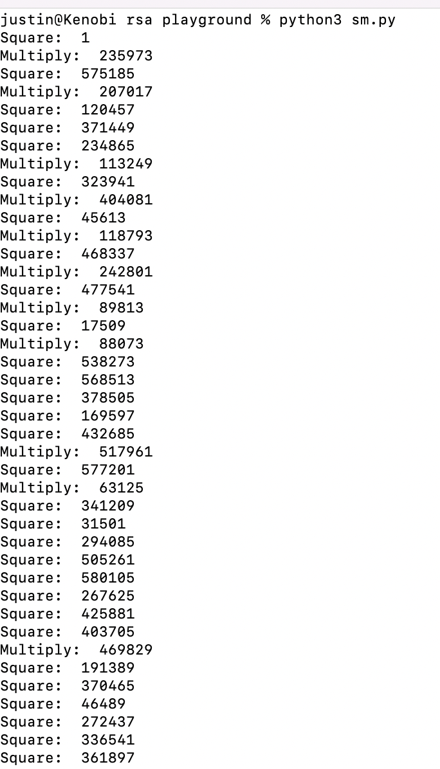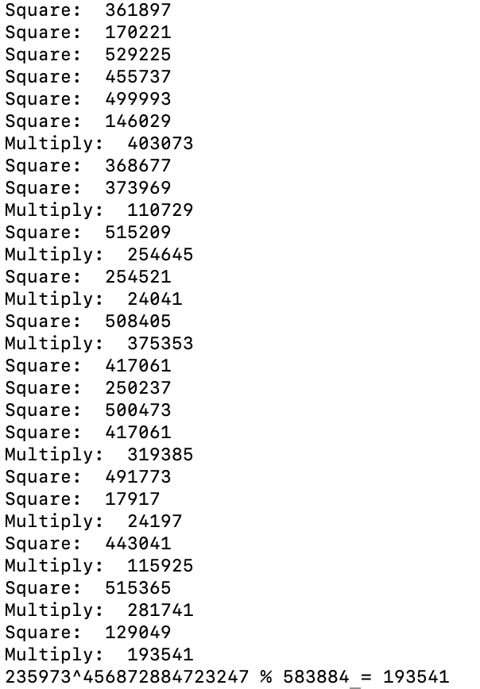

(b) a = 984327455683, b = 1253489582, N = 994348472542

